**17. ReactJs - HOL**

**1.Explain how to consume REST APIs from React applications**

* Use JavaScript methods like fetch() or libraries like axios to make HTTP requests.
* Call the API inside lifecycle methods (e.g., useEffect() for functional components).
* Store the API response in state using useState() and render the data in JSX.

**React Application – fetchuserapp**

Create a React Application “fetchuserapp” which will retrieve the user details from <https://api.randomuser.me/> and display the title, firstname and image of a user.

Create a component named “Getuser” and in the asynchronous method “ComponentDidMount ()” invoke the URL using fetch method and the response can be displayed in the render method of the component.

Code Snippet in Getuser Component:

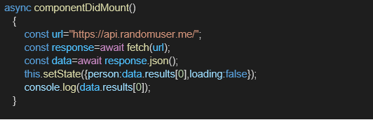

**Output:**

